SOLUTION REQUIREMENTS
Team ID: SWTID-2026-3491 | Date: 1 October 2026
Project: Import Data using Transform Maps (Spreadsheet)
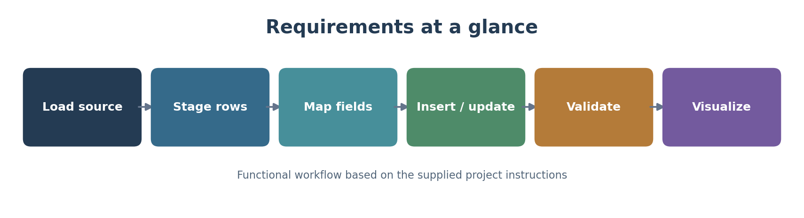
Functional requirements
ID | Requirement | Verification
FR-01 | Accept employee data from an Excel spreadsheet using Load Data. | Rows appear in Employee Import staging table.
FR-02 | Create Employee Test (u_employee_test) with Employee ID, Employee Name, Email, Department and Location string fields. | Fields are visible on the target form/list.
FR-03 | Create Sample Spreadsheet Import Transform Map from Employee Import to Employee Test. | Source and target tables are correct; fields are mapped.
FR-04 | Execute transformation and validate imported records. | Success state and records are visible in Employee Test.
FR-05 | Enable Coalesce on Employee ID to handle repeat imports. | Matching IDs update; new IDs insert; repeated unchanged rows are reported as ignored.
FR-06 | Create Employees by Department (pie/count), Employees by Location (bar/count), and Employee List Report. | Each report runs and saves with specified grouping/columns.
FR-07 | Create Employee Analytics Dashboards and add all three reports. | Dashboard displays the three reports.
Quality and operational considerations
Area | Requirement / source-supported check
Data integrity | Validate field mapping and compare transform history with Employee Test rows.
Repeatability | Re-run the same spreadsheet and inspect inserted, updated and ignored outcomes.
Usability | Arrange target list columns using Personalised List Columns.
Access | Dashboard creation via backend form depends on the documented ACL/Admin Overrides access; use permitted access.
Out of scope / unspecified | The source does not specify performance thresholds, external APIs, hosting, or security-role design beyond the dashboard ACL note.

